Project on Orchestration and Scaling

COMPLETE EXECUTION ROADMAP
User → Frontend (React)
↓
Backend (Node.js API)
↓
MongoDB
All running in Kubernetes (EKS)
Images stored in ECR
Built via Jenkins

STEP 1: Git Setup (Forked & Synced)
👉 https://github.com/UnpredictablePrashant/StreamingApp
Then Cloned my fork:
git clone https://github.com/fancy1505/StreamingApp.git
cd StreamingApp
- Added upstream (VERY IMPORTANT for syncing):
git remote add upstream https://github.com/UnpredictablePrashant/StreamingApp.git
- Sync when needed:
- git pull upstream main

STEP 2: Containerize MERN App

First created Backend Dockerfile
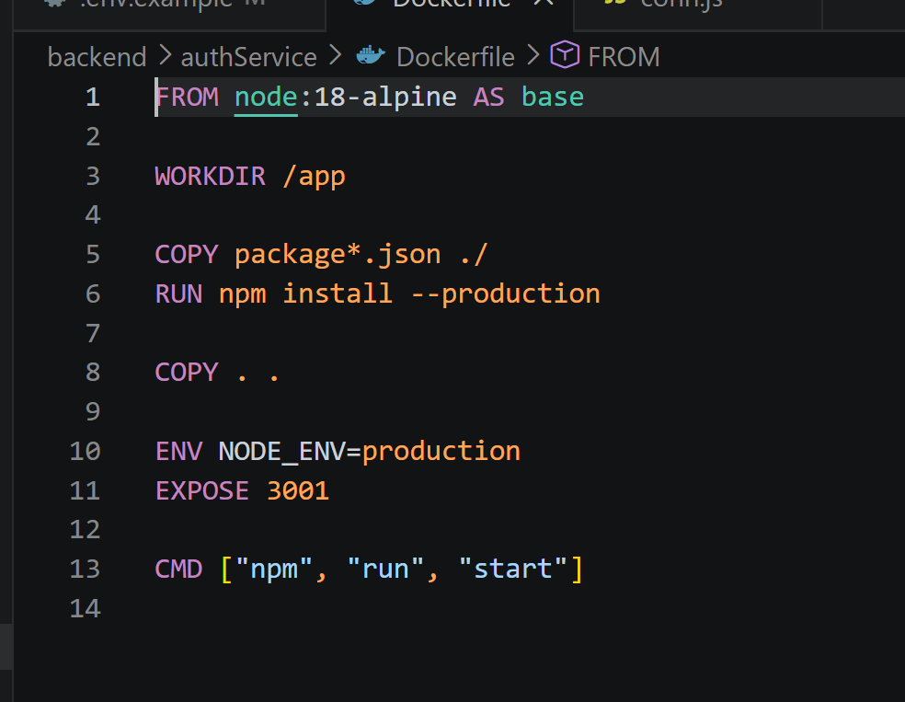
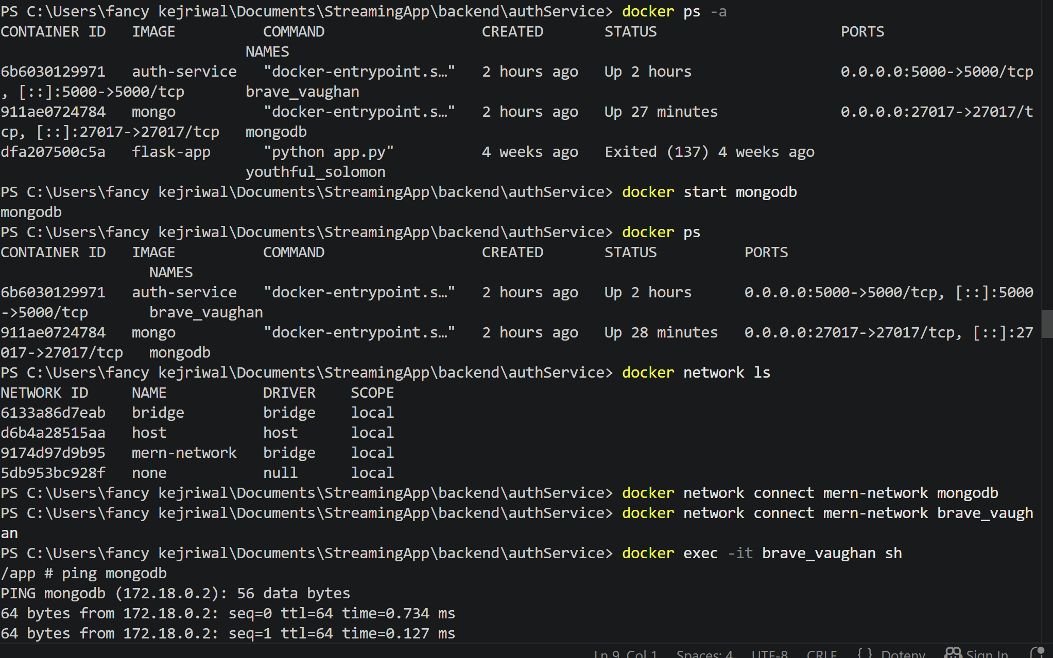
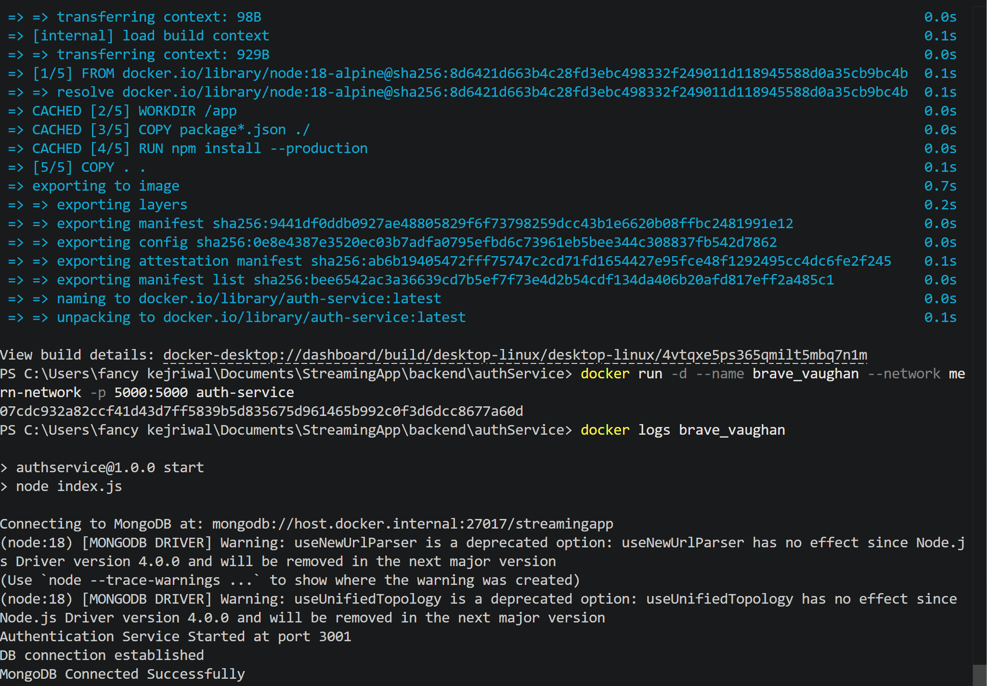
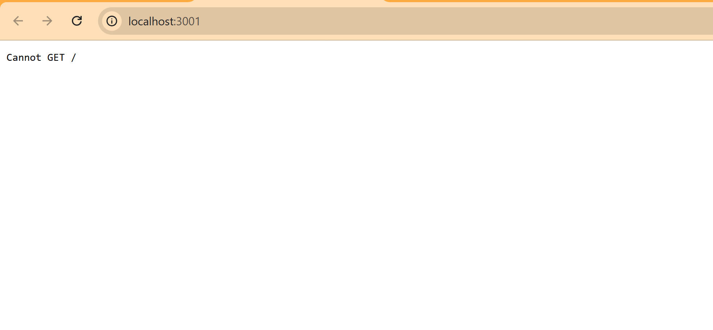

There was a issue connecting mongodb and network so resolved the issue while changing the mongo URI
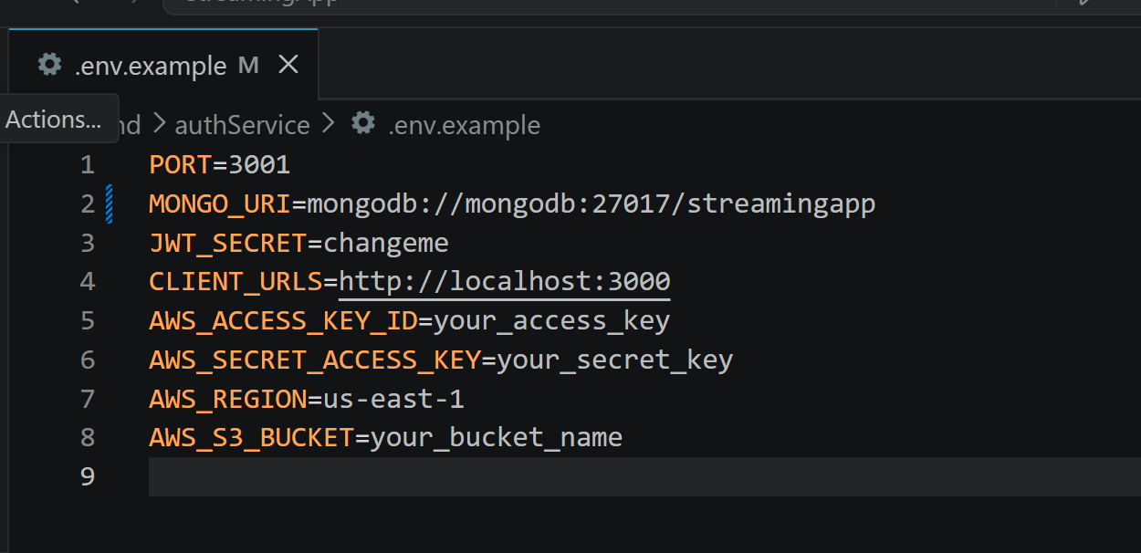
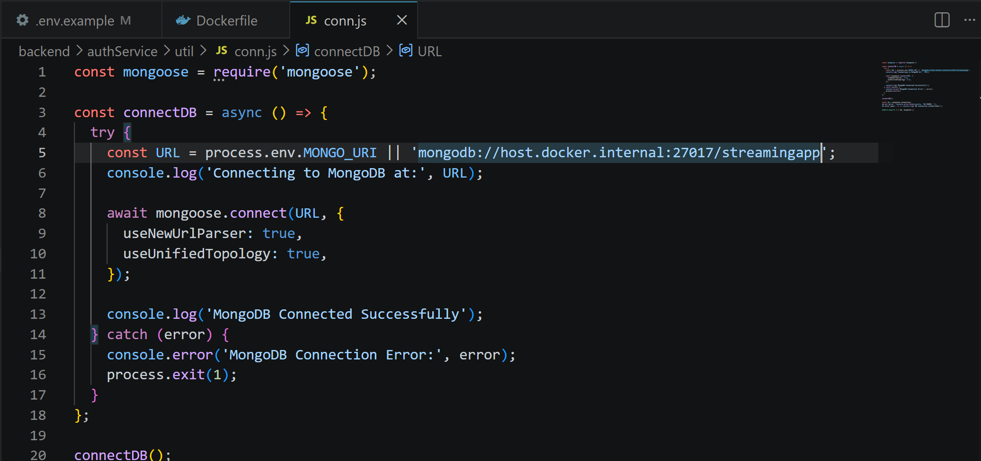

Now we will create Frontend Docker file
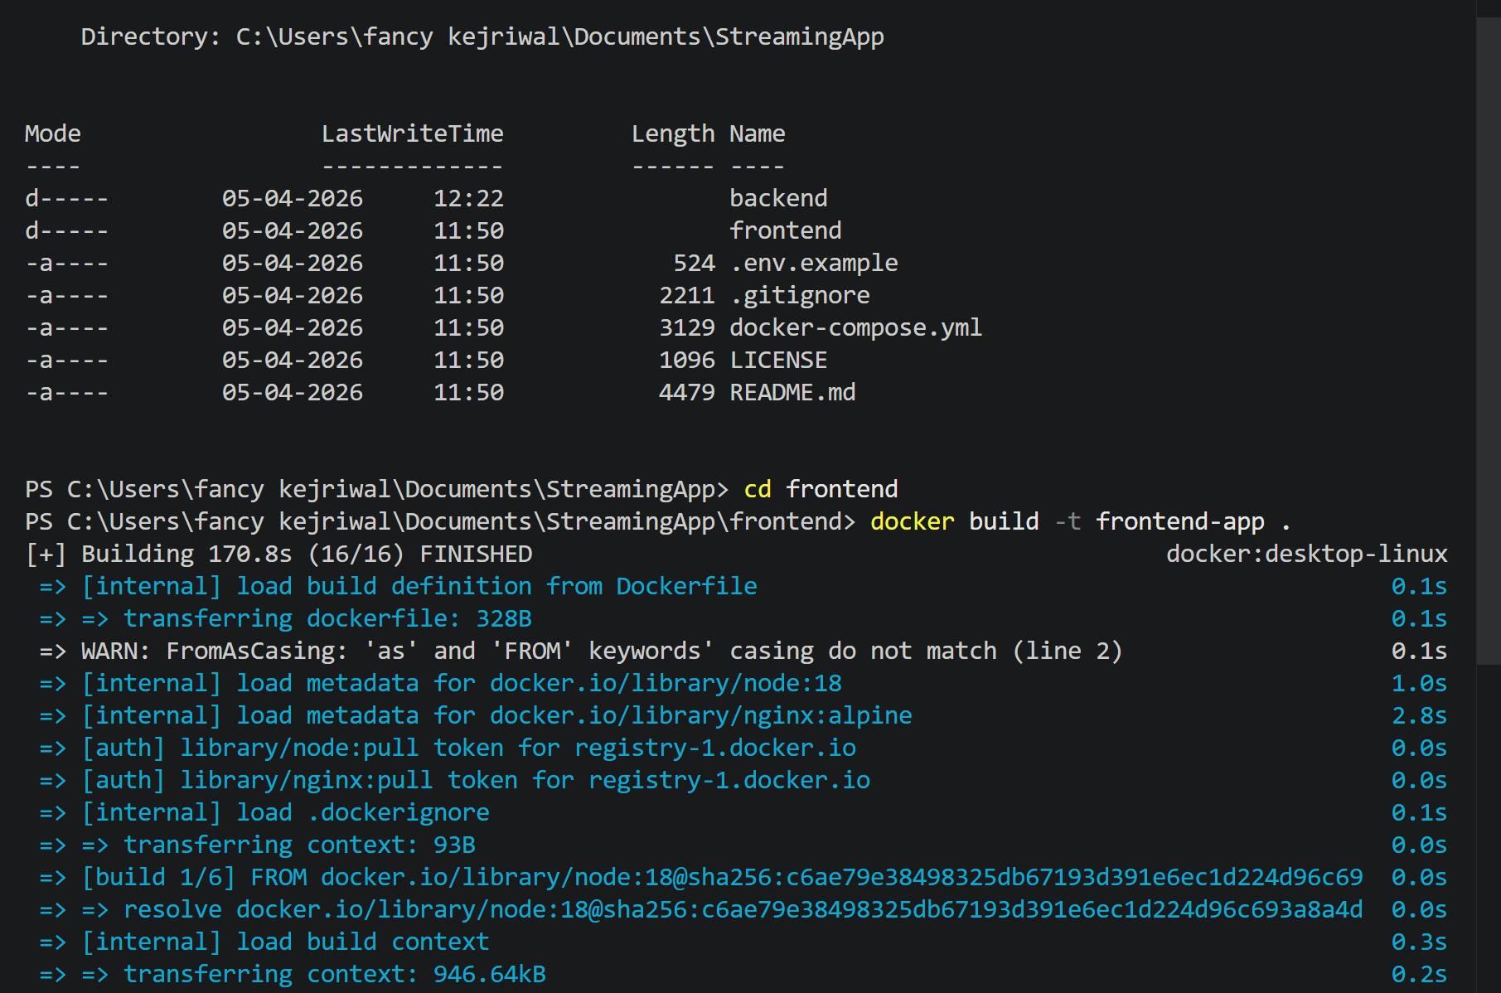
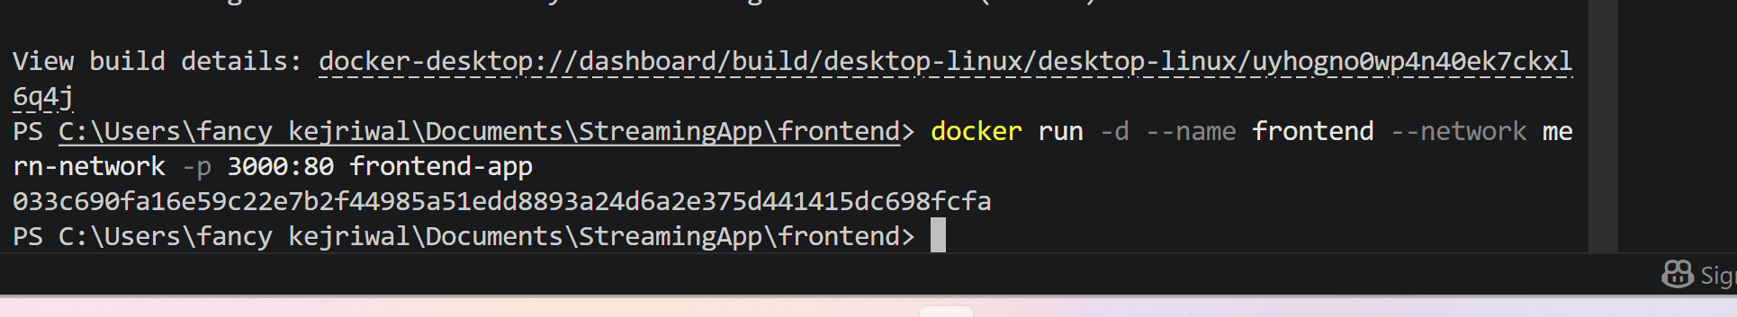
EXPECTED OUTPUT
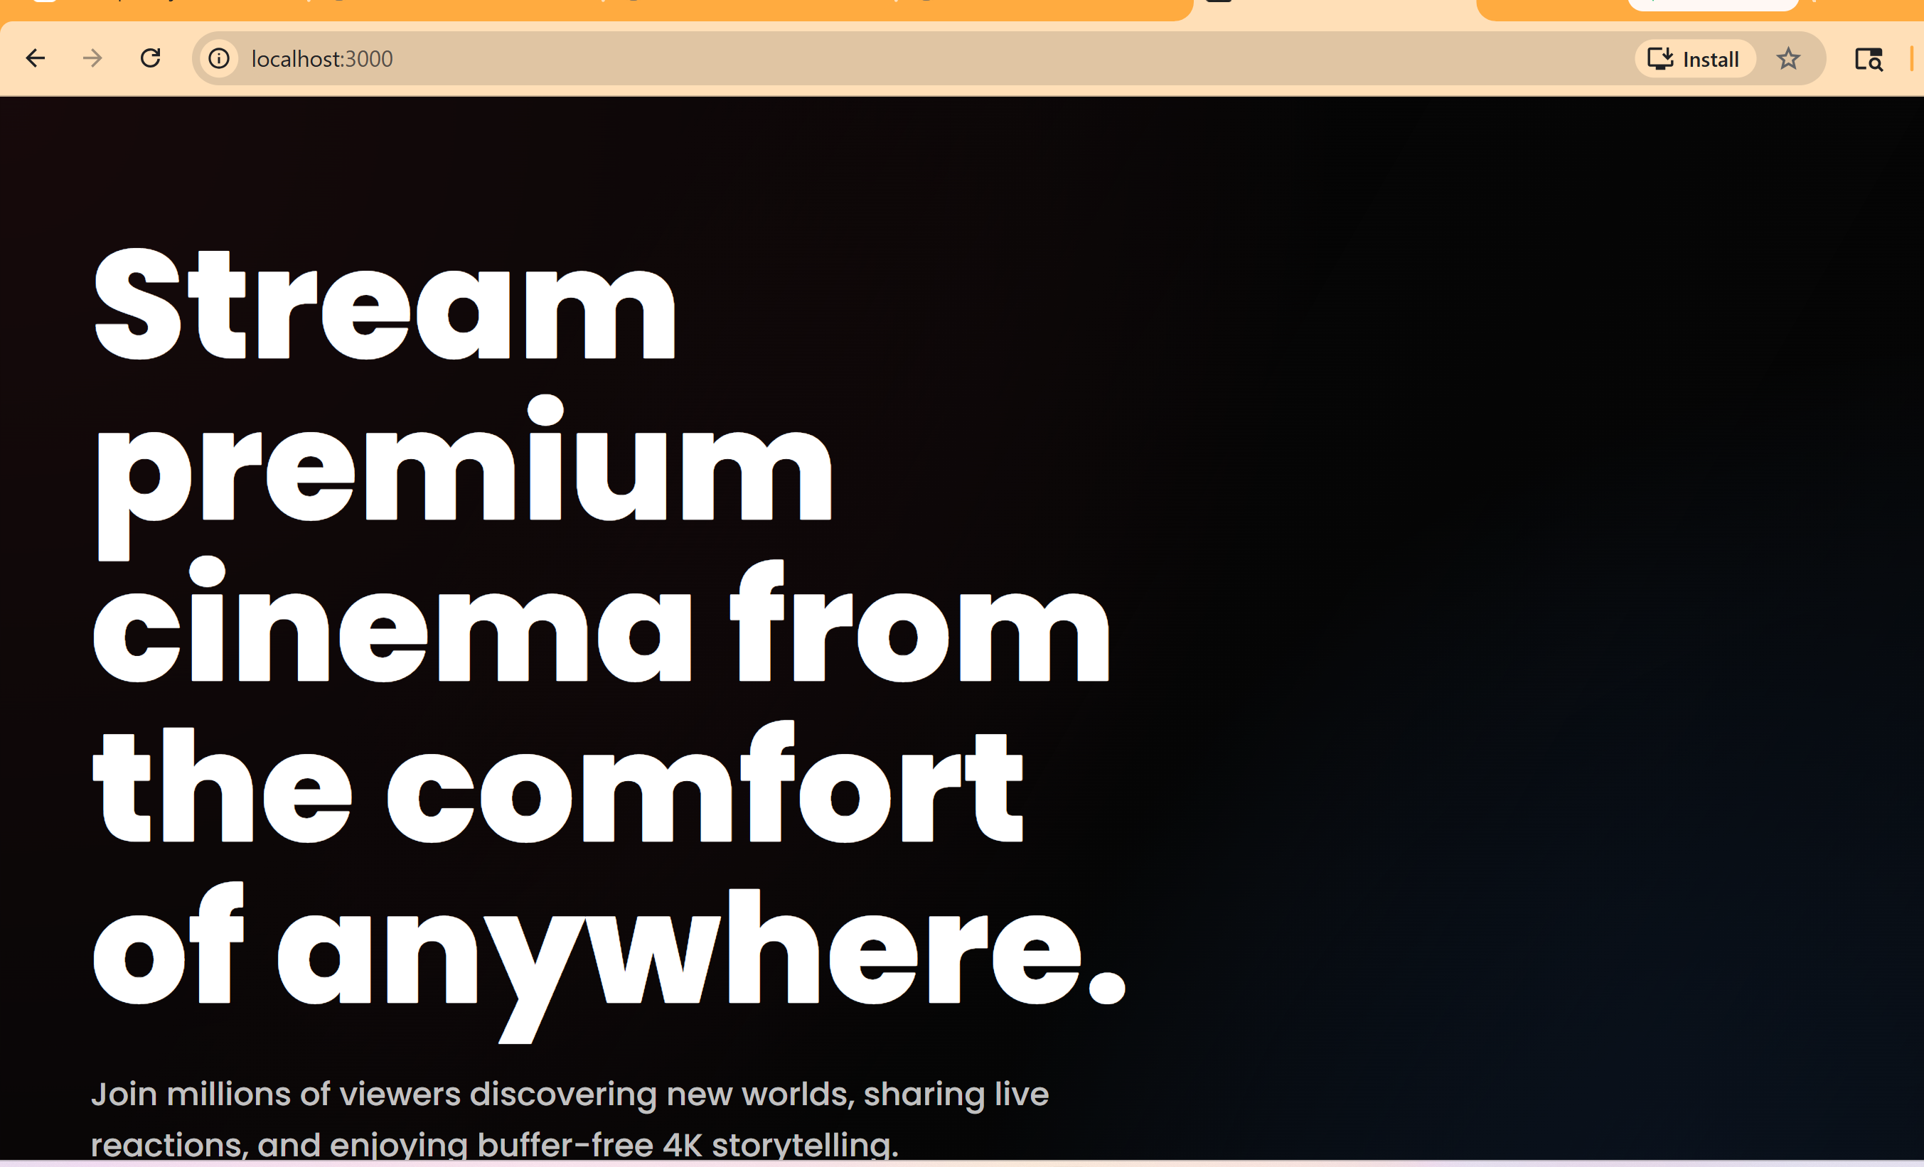

Till now we have completed
✔ Backend Docker ✅
✔ MongoDB connection ✅
✔ Docker networking ✅
✔ Frontend Docker ✅
✔ Full MERN app running locally ✅

Step 3: AWS ECR configuration
1.Created ECR repos
2: Login Docker to AWS
3: Pushed images
So first I have created IAM user and assigned security credential to login via Aws CLI
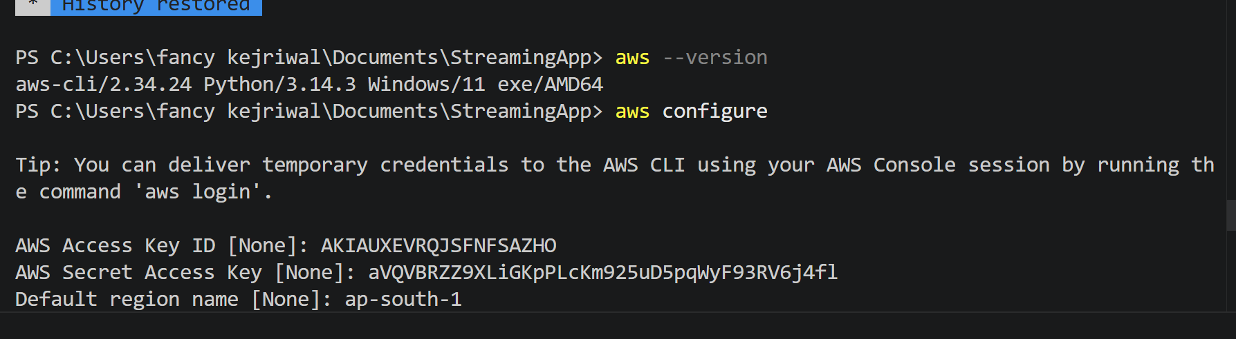
Created ECR Repositories
We’ll create 2 repos (as per assignment)

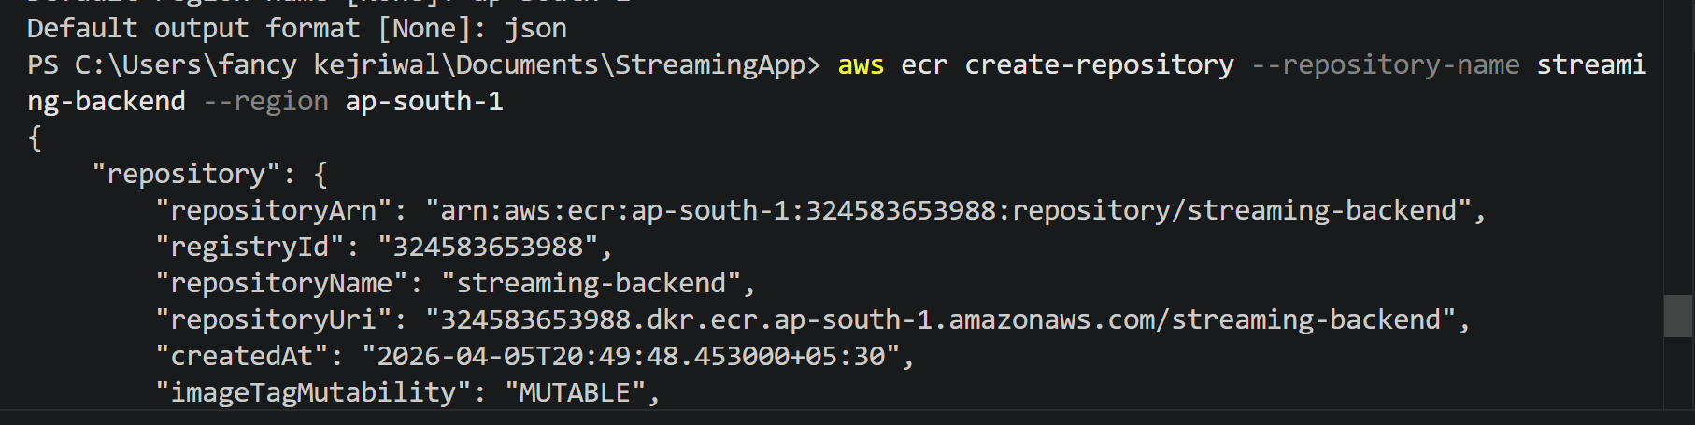
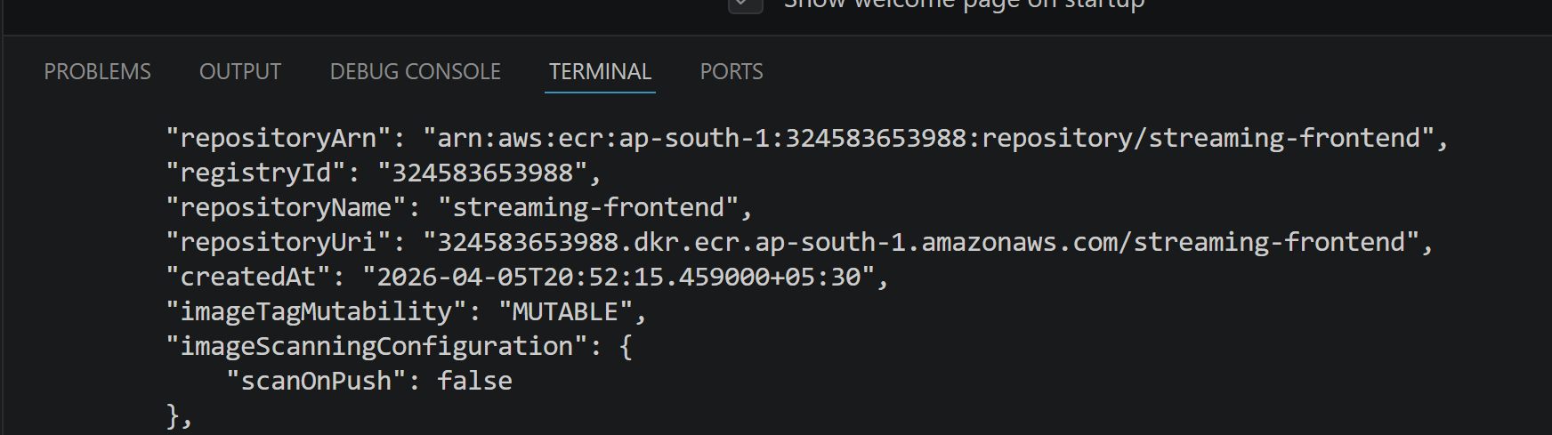
NEXT STEP: LOGIN DOCKER TO Amazon Web Services

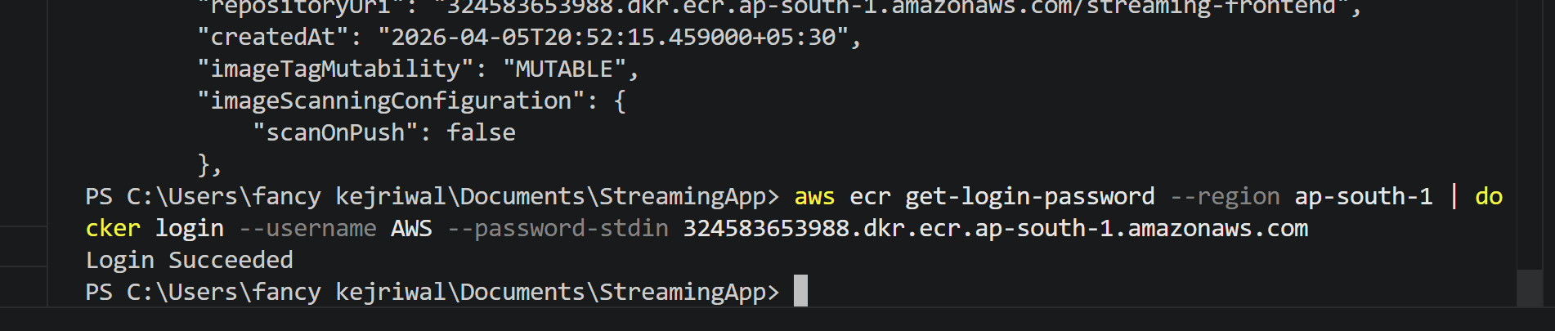

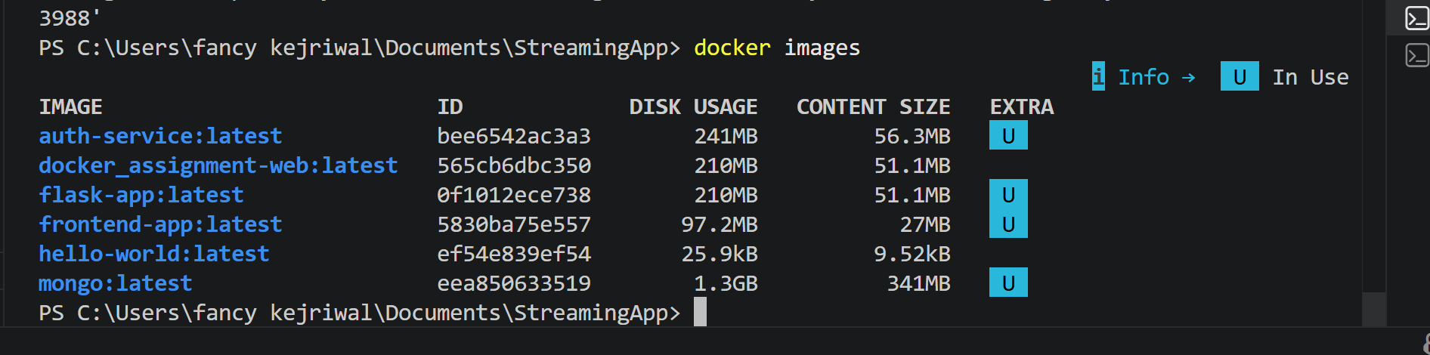
STEP: TAG YOUR IMAGES
Tagging = renaming image for ECR
TAG BACKEND
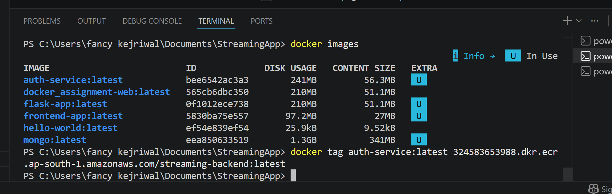

TAG FRONTEND
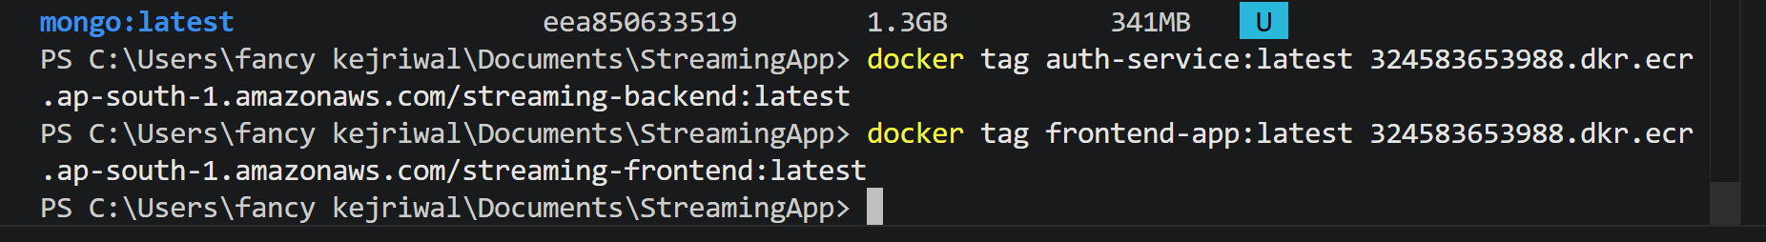

STEP 2: PUSH IMAGES TO ECR
PUSH BACKEND
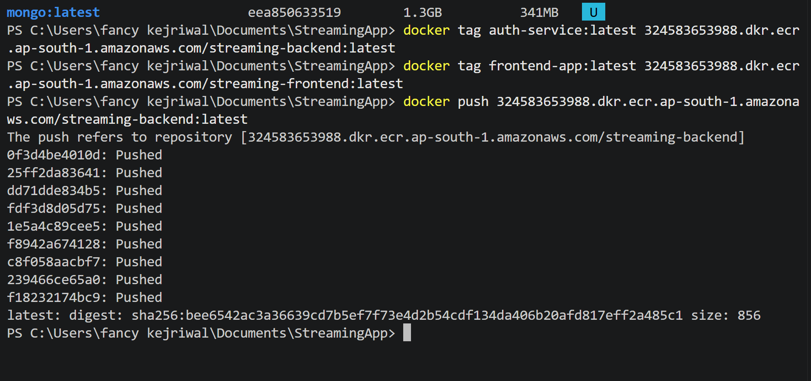

PUSH FRONTEND
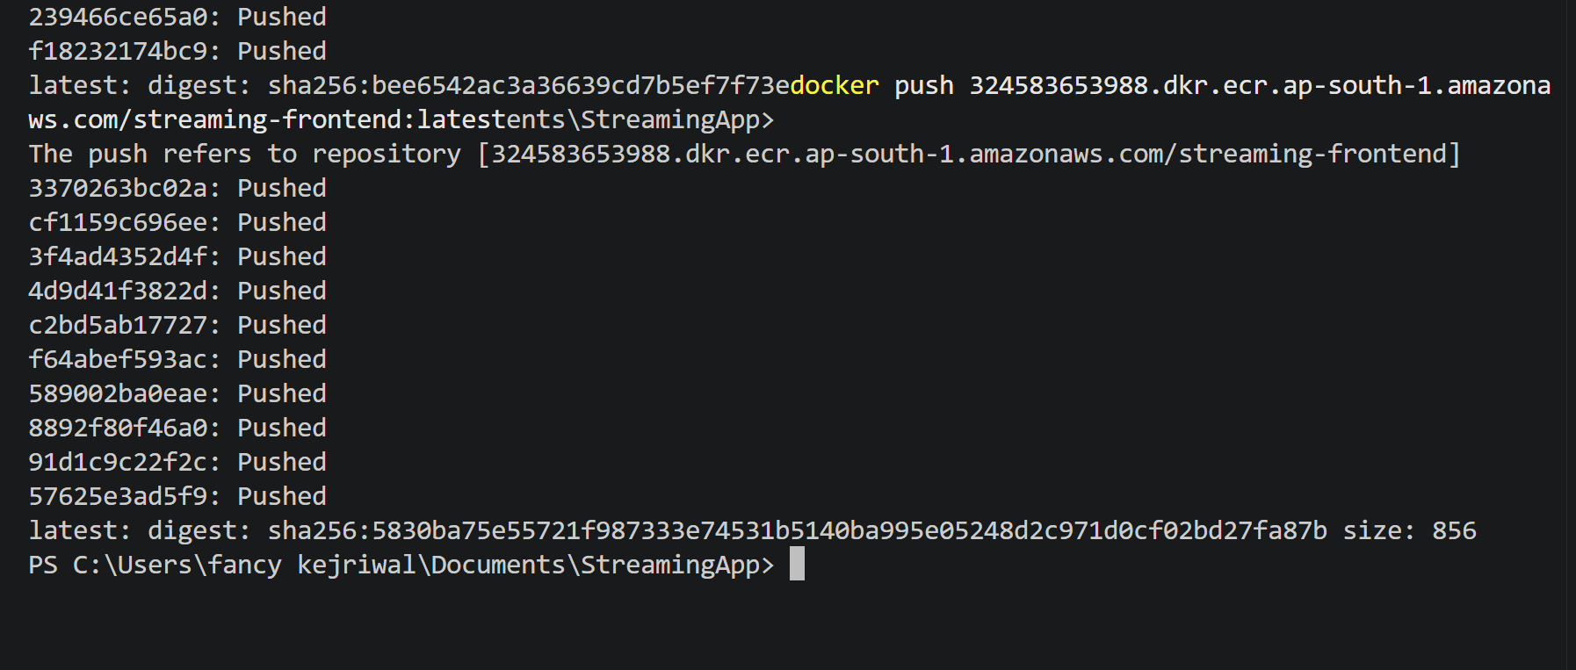
Verifying in AWS CONSOLE
Checking ECR → Repositories
Click:
- streaming-backend
- streaming-frontend
